IP CABLING TRANSMISSION – Active Series
ITEM NO.: IP01P POE Extender over Coax
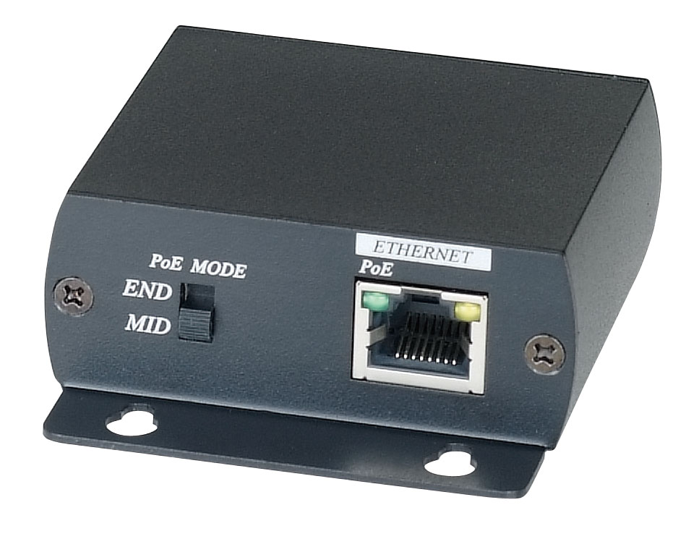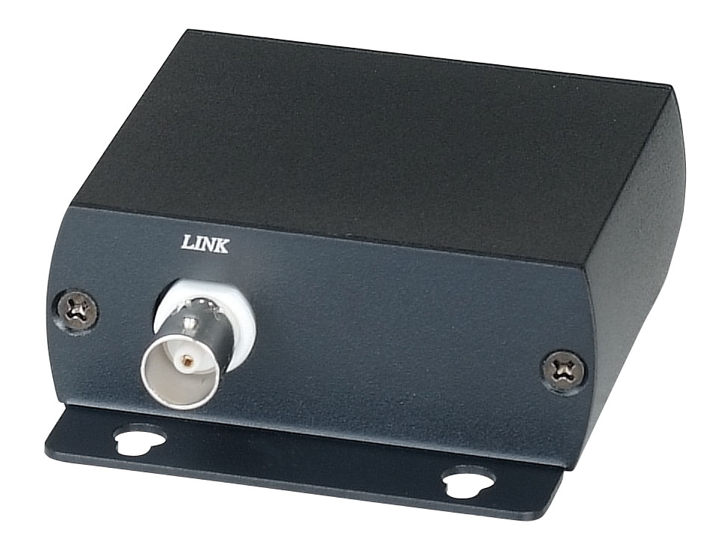
IP01P Extender is designed to send and extend IP/POE camera or any TCP/IP 10/100BaseT devices over existing coax cable. The distance could up to 300 meters by RG6U 75Ω Coaxial Cable. They are completely transparent to protocols, codes, and applications ensuring compatibility with any IP, POE camera and its management software. It is perfect solution to replace the analog camera to IP/POE camera using existing coax cable.
IP01P POE Extender over Coax 300M
- To extend IP/POE camera over coax cable.
- Connects IP/POE camera to 10/100BaseT POE Injector/Switch over one coax cable.
- Support POE: IEEE 802.3af and IEEE802.3at
- Support 10/100 Mbps transmission rate.
- Power source from POE Injector/ POE Switch (order separately)
- IP01P Power Source Option Model: POE Injector/Switch: IP05I/IP05H/IP06H/IP06I

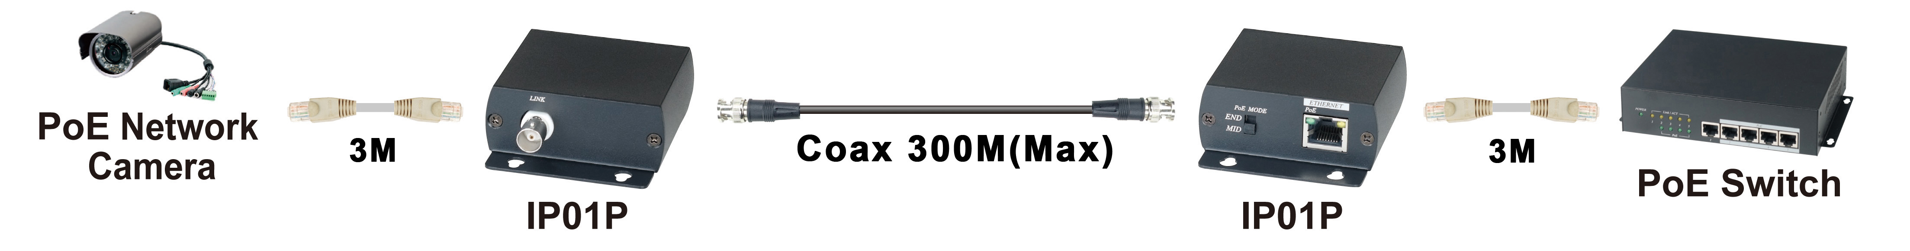

Transmission Distance Chart：

Coax Cable | Distance | Link Speed | Power Output
Coax Cable | Distance | Link Speed | PoE IEEE802.3af. | PoE IEEE802.3at
RG59 | 100M | 10Mbps | 10W | 20W
RG59 | 200M | 10Mbps | 7W | 18W
RG6U | 100M | 100Mbps | 10W | 20W
RG6U | 200M | 10Mbps | 7W | 18W
RG6U | 300M | 10Mbps | 5W | 15W

Cable:
Link cable use high quality 75Ω coaxial RG59, RG6U cable.

LED Indication:

Green ： Power ON/OFF

PoE MODE Switch：
END SPAN Using RJ45 Ethernet pin1 / 2 and 3/ 6 to send Power.
MID SPAN Using RJ45 Ethernet pin 4 / 5 and 7/ 8 to send power. (Recommend Setting)

Caution：
1. IP01P only works with PoE devices; please make sure the POE mode before connecting the power.
2. When doing switching MIS-SPAN and END-SPAN mode, please make sure unplug the power to avoid any damage.
3. Use RG59 cable, the link speed max up to 10 Mbps
3. The Ethernet cable between IP01P unit and POE equipments must less 3 meters.
4. If the distance over 100M, please manual setting the link speed to 10Mbp.

Panel View:

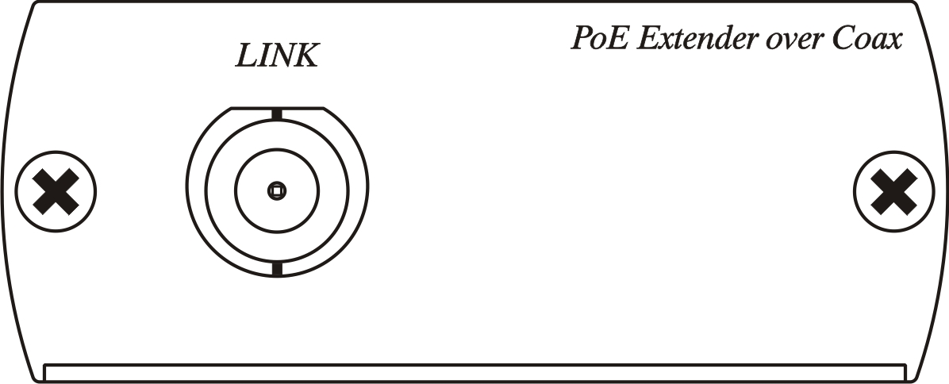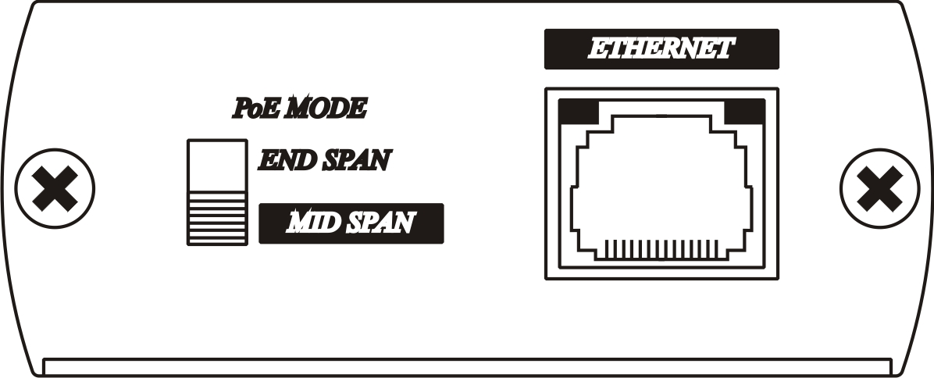

Specifications:

Item NO. | IP01P
Link Connector | BNC x 1
Ethernet Connector | RJ45 x 1
Linking Cable | 75Ω coax cable
Ethernet Speed | 10/100 Mbps
Transmission Distance | 300M(Max)
PoE Standard | IEEE 802.3af and IEEE802.3at
PoE Mode Setting | MID-SPAN、END- SPAN
LED Indication | Power (Green) x 1
Power Consumption | 1.25W (Max.)
Temperature | Operation: 0 to 55℃, Storage: -20 to 85℃, Humidity: up to 95%
Dimension mm | 67 x 87 x 27
Weight g | 150

Rev.A

